Chapter 19, Solution 21.

To get 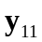 and 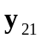, refer to Fig. (a).
At node 1,
0.2 V₁
5 
(a)
+
V₂ = 0
−
V₁
+
−
I₁
I₂
10 
V₁
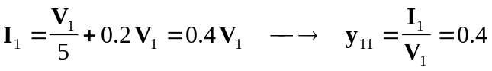

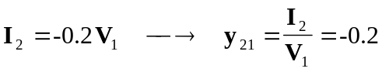

To get 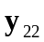 and 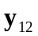, refer to the circuit in Fig. (b).
+
V₁ = 0
−
+
−
I₁
I₂
V₂
0.2 V₁
5 
(b)
10 
V₁

Since 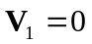, the dependent current source can be replaced with an open circuit.

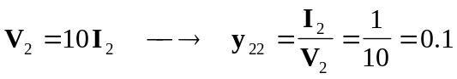

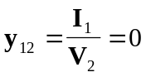

Thus,
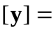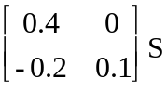

Consequently, the y parameter equivalent circuit is shown in Fig. (c).
0.1 S
0.2 V₁
+
V₂
−
+
V₁
−
I₁
I₂
(c)
0.4 S

